Sliding Window Technique

🔹 1) What it is Sliding window ?
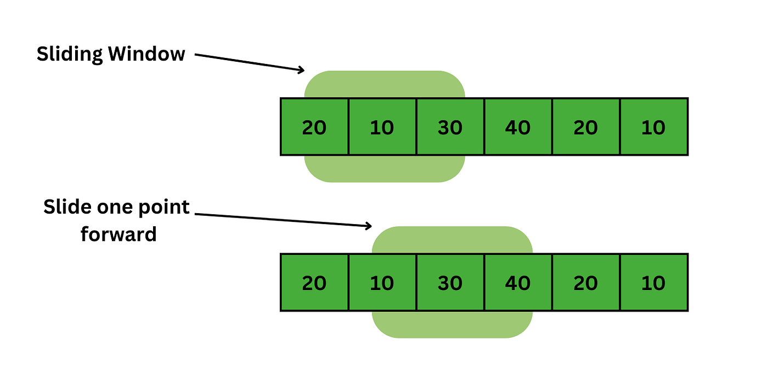
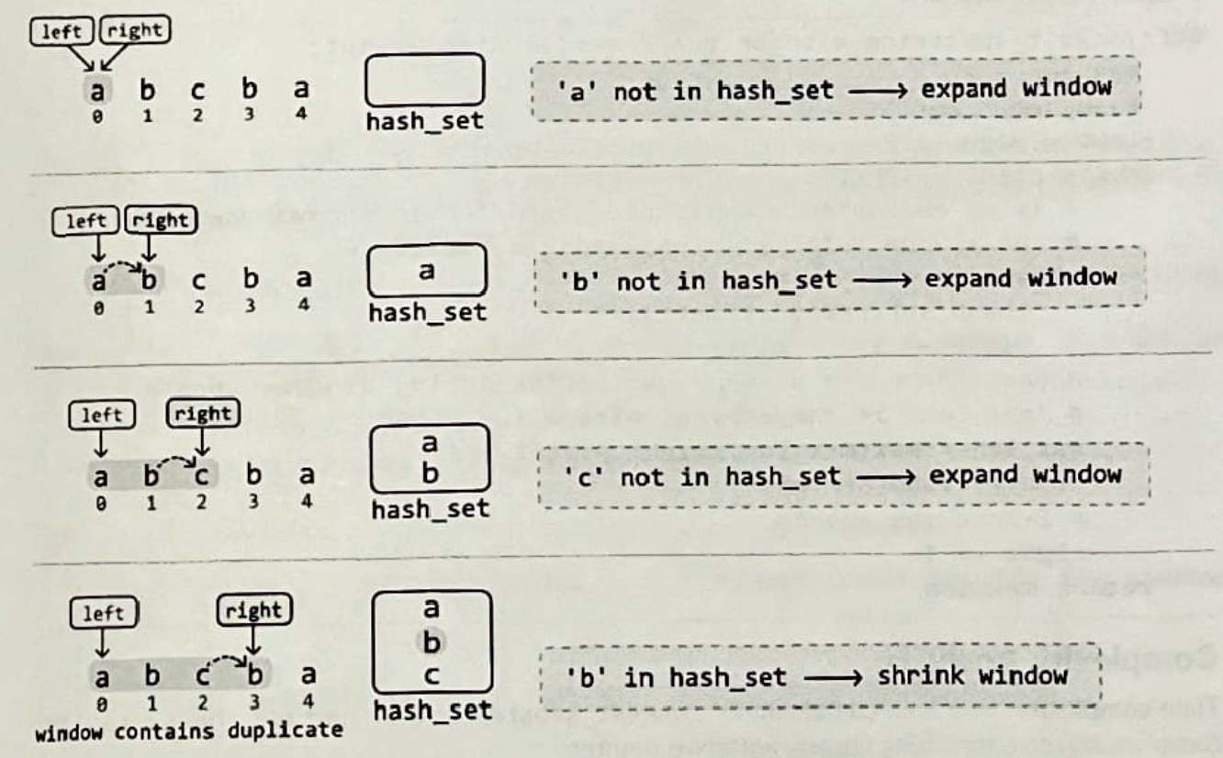

Sliding window is an optimization strategy for problems that deal with continuous segments in arrays or strings.
Instead of generating every possible subarray or substring and recomputing values repeatedly, we maintain a moving range and update information as elements enter or leave that range.
This often reduces:
O(n²) → O(n)

🔹 2) Uses
This technique is extremely common in interview questions involving:
- longest or shortest
- maximum or minimum
- substring or subarray
- constraints like at most k or exactly k
- distinct elements
- replacements or flips
Whenever continuity is mandatory, sliding window should be considered.

🔹 3) Working Principle
We maintain two boundaries:
left → beginning of the window
right → end of the window
General behavior:
- move right to include more data
- if condition becomes invalid, move left
- keep the window valid
- update the answer at the proper time
Each element usually enters and exits once, giving linear complexity.

🔹 4) Typical Approach (Conceptual)
- Start with both boundaries at the beginning
- Expand the range by moving the right boundary
- Track necessary information such as counts or sums
- If rule breaks, shrink from the left
- Continue until the end

🔹 5) Types of Sliding Window
1️⃣ Fixed Size Window
The length of the range is constant.
Common in:
- average calculations
- maximum or minimum sum of size k

2️⃣ Variable Size Window
The range expands and shrinks based on constraints.
Common in:
- longest substring problems
- minimum covering problems

3️⃣ Frequency Based Window
Maintain occurrence counts of characters or numbers.
Often uses:
- hash maps
- frequency arrays

4️⃣ Constraint Based Window
Examples:
- at most k distinct
- sum greater than or equal to target
- k modifications allowed

🔹 6) Recognition Hints
You will likely use sliding window if:
✔ data must be contiguous
✔ removing the leftmost item can restore validity
✔ brute force would require nested loops
✔ the problem asks for optimization within a range

🔹 7) Complexity
Most sliding window problems run in:
Time → O(n)
Space → depends on stored information, often small or proportional to character set.

🔹 8) Interview Expectation
Interviewers want to see whether you:
- maintain dynamic state
- avoid recomputation
- know when to expand vs shrink
- update results correctly

🔹 9) Frequently Asked Practice Problems
Easy
- Maximum Average Subarray I
- Best Time to Buy and Sell Stock
- Contains Duplicate II

Medium
- Longest Substring Without Repeating Characters
- Max Consecutive Ones III
- Longest Repeating Character Replacement
- Minimum Size Subarray Sum
- Permutation in String
- Fruit Into Baskets

Medium to Hard
- Binary Subarrays With Sum
- Number of Substrings Containing All Three Characters
- Subarrays with K Different Integers

Hard
- Minimum Window Substring
- Substring with Concatenation of All Words
- Sliding Window Maximum

